CHAPTER ONE
- INTRODUCTION
Data mining is the process of finding previously unsuspected patterns in information contained in large database. The major reason why data mining has a great deal of attention in the information industry in recent year is due to the wide availablility of high amount of data and the information and knowledge gained can be used for application ranging from production controls and market analysis business management engineering design and science exploration (Amazon, 2005). Data mining can be viewed as a result of the natural evolution of information tehnoolgy because before 1960 when database and information technology had not evolved analysis of data was basically the primitive file processing which could not give the appropriate useful information despite the huge amont of the time consumed the evolutionary path of data mining as been witnessed in the database industry in development of the following databased and information technology are data collection and database creation, data management (including data warehouse and data preparation) and data analysis and understanding (involving data mining and data interpretation) (David reilly,2004).
Moreover data mining is also known as Knowledge Discovery in Database (KDD). Consequently data mining consist of more than collection and managing data, it also include analysis and predictions (Anderson, 2006).
It is a research area at the intersection of several disciplines, including statistics, database, pattern recognition, neural network, visualization, optimization, and high-performance and parallel computing. With the success of database systems, and their widespread use, the role of the database expanded from being a reliable data store to being a decision support system (DSS) (David reilly,2004).
Data mining simply refers to extracting or “mining” knowledge from large amount of data. It is the process of finding correlations or patterns among dozens of field in large relational database. Data mining is unlike a data only perform data or information retrieval, or that performs deductive query answering in large database, but it combines machine learning, high performance computing, pattern recognition, neural networks, data visualization, information retrieval image and signal processing and spatial data analysis (Frawley, 1992).

1.1 Background to the Study
Presently, the Data Mining Based Analysis of Students Academic Performance of Computer Science Department in Osun State Polytechnic, Iree employs the manual approach in analysis of students’ academic performance. Such analyses are made by deliberating on the analysis of students academic performance carried out on student results. This approach as been found to be associated with problems scuh as curmbsome, time wasting and eventual delay in analysing of students’ academic performance.
Hence, there is a need to develop an automated system that is capable of assisting the management in making timely data mining based analysis of students’ academic performance of Computer Science Department in Osun State Polytechnic, Iree.

1.2 Statement of the Problem
Investigation has revealed that there is no automated system of analysis of student academic performance made on processing Data Mining Based Analysis of Students Academic Performance of Computer Science Department in Osun State Polytechnic, Iree.
Hence, in this project work a Data Mining Based Analysis of Students Academic Performance that is capable of analysing the students academic performance in making effective analysis on Students Academic Performance of Computer Science Department in Osun State Polytechnic, Iree was designed, implemented and evaluated.

1.3 Aim and Objectives of the Project
The project is aimed at developing a Data Mining Based Analysis of Students Academic Performance of Computer Science Department in Osun State Polytechnic, Iree.
The specific objectives of the work include:
i. To design a Data Mining Based Analysis of Students Academic Performance of Computer Science Department in Osun State Polytechnic, Iree.
ii. To implement the designed system in (i) above using Visual Basic programming language and Microsoft access for the database.
iii. To evaluate the performance of developed system by compazering it with the existing approach of Analysis of Students Academic Performance.

1.4 Significance of the Study
The implementation of Data Mining Based Analysis of Students Academic Performance is very significant and relevant in any academic institution where record of each student has been collected and stored in a databased system the need for data mining in analysis of students academic performance.

1.5 Scope of the Study
The project is aimed at creating a very good Data Mining Based Analysis of Students Academic Performance that will ease the work of the management of the school and allow the effectiveness of a good analysis of students academic performance designed.

1.6 Research Methodology
The methods used for caring out the project work are as follows:
i. An establishment of a theoretical foundation for the project work through a sound review of relevant literatures on Data Mining Based Analysis of Students Academic Performance of Computer Science Department in Osun State Polytechnic, Iree.
ii. The design of Data Mining Based Analysis of Students Academic Performance of Computer Science Department in Osun State Polytechnic, Iree.
iii. The implementation of the designed system in (ii) above using Visual Basic Programming Language and Microsoft access for the database.
iv. Evaluation of the performance of the newly developed system based on accesibility and usability of the system.

1.7 Definition of Terms
Data mining: is the process of finding previously unsuspected patterns in information contained in large database.
Record: A thing constituting a piece of evidence about the past, especially an account of an act or occurrence kept in writing or some other permanent form.
Registration: The action or process of registering or of being registered.
Database: It is an organized collection of data for one or more purpose usually in digital form.
Data: Are the basic facts about an entity which have no special meaning until they are process and transform into information.
File: Is the collection of organized related records.
Student Bio-Data: This can be a particular of each student e.g. sex, date of birth, etc.
Ill-Structure Problem: means the way by which some portion of record is being disarranged or disorganized.
Discovery in Database;- is the process of identifying valid, potentially useful and ultimately understanding structure in data
Client: can send a query to server the client could run on personal computer.
Data Administration System;- help users manage the overall database environment by providing facilities for backup and recovery, security managemnt query optimization, concurrency control and change management
Support: This helps the committee and encourages them by saying or showing that the user has agree with them.
System: This is group of component that function has an operating system. It accepts data manipulate it and produce it output.
Distributed Database System: It offers many advantages compared to centralized database system and manual system of record keeping.
A Database Management System: A collection of program that enable users to create and maximize database.

CHAPTER TWO
- LITERATURE REVIEW
2.1 Introduction
Data mining (sometimes called data or knowledge discovery) is the process of analyzing data from different perspectives and summarizing it into useful information as more data is gathered with the amount of data doubling every three years, data mining is becoming an increasingly important tools to transform this data information it is commonly used in a wide range of profiling practices such as marking surveillance fraud detection and scenic discovery. (Filo,1982).
Data mining can be used to uncover patterns in data sample. It is important to be aware that the use of non-repesesentative sample of data may produce results that are not indicative of the domain. If those patterns are not present in sample being “mined” there is tendency for insufficiently knowledgeable “customers” of the result to attribute magical abilities to data mining, treating the techniques as a sort of all seeing crystal ball (Sgelio, 1992).
Although data mining is a relatively new terms; the technology is not for many years. Business scientists and government have used powerful computer to sift through volunes of data such as airline passenger trip records census data and supermarket scanner data to producer market reseach reports (note, however, that reporting is not always consider to be data mining). (Solio,1985).
However continuous innovations in compuer processing power disk storage data capture technology; algorithms methodologies and analysis software have dramatically increased the accuray and usefulness of the extracted information(David reilly,2004).

2.2 Result Validation of DataMining
The final step of knowledges discovery from data is to verfy the patterns produced by the data mining algorithms occur in the wider data set. Not all patterns produce by the mining algorithms are necessary valid it is common for the data mimning algorithms to find tranining set which are not present in the general data set, this is called over fitting to overcome this the evalution uses a test set of data which the mining algorithms was not trained on. A number of statistical methods may be used to evaluate the algorithms such as ROC curve(Sprague,1982).
If the leant patterns do not meet the desired strandard, then it is necessary to revaluate the preprocessing and data mining. If the leant patterns meet the desired standards then the final step is to interpret the leant parttern and turn them into knowledge(David reilly,2004).
The time consumption during the process but later with the aid of software application programs, the computer became useful in so many areas of specialization for instance von Neumann went in to research in order to develop a machine that is able to store information which is still utilized till today(Carlson,1982).
As the use of computer begine to advance, people begine to reason to store large information such as record, files, picture, and audio on the computer and later updating the stored information, this lead to the development of the file structure concept(Sprague,1982).
Information can be stored for future purpose in so many ways and the methods of storage advances time to time because of large accumulation of data being collected which required memory space to collect such data information can be stared on flash drives, magnetic disks, hard and floppy disks(Sprague,1982).

2.3 File Structure
The file is a concept that was developed to allow computer users and scientists to store, this concept uses a plain text editor its operation and it is widely used till data by those that or information is been stored or handled(David reilly,2004).
The two of file structure are as following:
- The Sequential File Structure
This is a kind of file structure that allows data to be stored in a serial format. It allocates equal space for every data that are stored into the system and these data are stored in sequence though the sequential file the advantages are that it saves space on the storage device when records ia a squenttail file are permitted to span blocks tha is, to cross blocks boundaries in this way records can be packed efficiently and avoid wasted apace at the end of the block(Hand,2001).
- The Random File Structure
This is a kind of of file structure that allows data to be stored on the hard disk in a random manner it is designed in such a way that the storage sequence of data is mintoerd and remember as the storage is processed in the system one after the other the random file structure is faster than the sequential file structure because a program can be accessed most likely result in an i/o operations (Mannila, 2001).
- Disadvantage Of Files Structure
The major problem that is attached to the file system is what is know as redundancy that is duplication of data of the same value which leads to waste of resources such as disk apace processor time and user time this problem was solved when concept of database was developed the shortcoming of file structure is seen when it cones to updating informational or deleting of data from the file (Smyth, 2001).
2.4 The Database
This is a storage structure which is created to solving the problem encountered in the file structured a database is a collection of interrelated data of different types an important feature of a good database is that unnecessary redundancy of stored data is avoided along with the constituency problems that redundancy creates(Frawley,1992).
Database could be flat that is non-relational as seen in COBOL language or relational as seen in oracle, Microsoft access MYSQL sever e.t.c there are several varieties of databases some which are:-

2.4.1 Data Warehouse
Dramatic advance in data capture processing power data transmission and storage capabilities are enabling organization to integrate their various database into data warehouse. Data warehousing is defined as a process of centralized data management and retrieval data warehousing like data mining is a restively new term although the concept itself has been around for years. Data warehousing represent an ideal vision of maintaining central information from different angles(Piatetsky,1992).
A data warehousing is a relational database management system (RDMS) designed specifically to meet the need of transaction processing system it is any centralized data repository which can be querid for business benefit and provides data is aldeadly transformed and summarized (statsoft,2005).
Some features of a data warehouse are:
- It is used by a broad spectrum of end users for a variety of purposes.
- It is repository for information and record results.
- Reduce the reorting and analysis impact on operational systems.
- Improves access to integrated data.
- Ensures integrity and quality.
- Requires a major systems integration effort
- Provides an historical perspective.
A data warehouse collects information about subjects that span an entire organization, and thus its scope is enterprises, while a data mart is a department subset of a data warehouse, it focuses on selected subjects and thus its scope is department-wide(Shapiro,1992).
Although data warehouse technology which consist of the OLAP tools support multi-dimensional analysis and decision making, additional data analysis tools are required for in – depth analysis, such as data classification, clustering and the characterization of data changes over time. This data analysis tool is called the data mining tool which performs strategies, knowledge and scientific and medical research(Matheus,1992).

2.5 Data Mining
Data mining simply refers to extracting or “mining” knowledge from large amount of data. It is the process of finding correlations or patterns among dozens of field in large relational database. Data mining is unlike a data only perform data or information retrieval, or that performs deductive query answering in large database, but it combines machine learning, high performance computing, pattern recognition, neural networks, data visualization, information retrieval image and signal processing and spatial data analysis (Frawley, 1992).



Data mining also refers to using variety of techniques to identify nuggests of information or decision making knowledge in bodies of data and etracting these in such as givens database is offer volumions but as it stands, it’s of low value as no direct use can be made of it it is the hidden information in the data that is useful (Clementine, 1988), by performing data mining interesting knowledge regulation or high-level information can be extrated from database and viewd or browsed from from different angles the discovered knowledge can be applied to decision making information management process control and query processing. Most data mining efforts are focused on developing a finely – grained, hihly detailed molel or some large dataset(Frawley,1992).

2.5.1 The Quality of Data Mining
Data mining dareves its name from the similarities between searching for valuable business information in a large database. For example finding linked products in gigbytes of stored data and mining a mountain for a vien of valuble is Bothe processes require either sifting through an immense amount of material or intelligently probing it to find exactly where values reside. Given databases of sufficient size and quality data mining technology can generate new business opportunites by providing theses capacicities such as;
- Automated prediction trends and behaviors data mining automated the process of finding predictive information in large database questions that quickly. A tyical example of a prdicitive problem is targeted targets most likely to maximize return on investment in future mailings other example are forecasting bankruptcy and other forms default and indentifying segments of population likely to respond similary to givien events(Matheus, 1992)
- Automated discovery previously unknown patterns data mining tools sweeps through database and indentify previously hidden patterns is one steps an example of pattern discovery is the analysis of retail sales data to identify detecting fraudulent credit card transactions and indentitying anomalous data that could represent data entry keying erros(Frawley,1992).

    - Techniques in Data Mining
Data mining techniques can yied the benefits of automates on, existing software and hardware platforms and be implemented on new system as exising platforms are automatically experiment with more models to understand complex data larger database, in turn yied improved prediction(Matheus, 1992).
Database can be larger in both depth and breath;
- More columns analysis must often limit the nember of variable they examine when doing hands-on analysis due to time constraints high performance data mining allows users to explore the full depth of a database without perslecting a susset of variables.
- More rows larger sample yied lower estimation error and varitance and low user to make intrefences about small but important segment of pollution(Fayyad, 1996).
A recent Gartenr Gorup Advanced Technology Research Note Listed data mining and artifical intellgence at the top of the five key tecology areas that will cliarty have a major impact across a wild range of industric within as next 3 to 5 yaers’ .Gartner also listed parallel arcgitectures and data mining as two of the top 10 new technologies in which companies will l invest during the next 5 years. According to a recent Gartner High Performance Computing Research Note” with the rapid advance in data capture, transmission and storage, large-systems users will increasingly need to implement new and innovative ways to mine the after-market value of the vast stores of detail data, employing advantage MPP (massively parallel processing) systems to create new sources of business advantage (0.9 propability)(Piatesky,1996).
The techniques used in data mining are”
i. Artificial neural networks: - Non-linear predictive models that learn through traning and resemble bilological neural in structure.
- Genetic algorithms: - Optimization technique that use processes such as genetic combination, mutation, and neural selection in a design based on the concepts of natural evolution.
- Decision trees: - Tree-shaped structures that represent sets of decision. These decisions generate rules for the Classification and Regression Trees (CART) and Chi Square Automatic Interaction Detection (CHAID).
- Nearest neighbor method:- A technique that classifies each record in a dataset based on a combination of the classes of the K recoeds(s) most similar to it in a historical dataset (where K=1). Sometimes called the K-nearest neighbor technique.
- Rule induction: - The extraction of useful if- then rules from data based on statistical significance.
- Data visualization: - The visual interpretation of complex relation in multidimentional data. Graphics tools are used to illustrate data relationships.
Data mining analysis tends to works from the data up and the best techniques are those developed with an orientation towards large volumes of data, making use of as much of the collected data as possible to arrive at reliable conclusions and decisions. The analysis process start with a set of data uses a methodology to develop an optional representation of the structure of the data during which time knowledge is aquire. Once knowledge has been acquired, this can be extended to large sets of data working on the assumption that the larger data set has a structure similar to the sample data(Shapiro,1996).
Therefore, data mining is also an essencial step in the process of Knowledge Discovery in Database (KDD).

2.6 The Foundations of Data Mining
Data mining can be viewed as a result of the natural evolution of information technology. Data mining techniques are the result of a long process of research and product development. This evolution began when business data was first stored on computers, continued with improvements in data access and more recently, generated technologies that allow users to navigate through their data in real time. It takes this evolutionary process beyond retrospective data access and navigation to prospective proactive information delivery(Smyth,1996). Data mining is ready for application in the business community because it is supported by three technologies that are now sufficiently mature:
i. Massive data collection.
ii. Powerful multiprocessor computers.
iii. Datamining algorithms.
Commercial databases are growing at unprecedented rates. A recent Meta group survey of data warehouse projects found that 19% of respondents are beyond 50 gigabyte level while 59% expect to be there by second quarter 1996 in some industries, such as retail, these numbers can be larger. Thr accompanying need for improved computational engines can now be met in a cost-effective manner with parallel multiprocessor computer technology. Data mining algorithms embody techniques that have existed for at least 10 years, but have only recently been implemented as mature, reliable, understandable tools that consistently out perform older statistical methods.
In the evolution, from business information, each new step has built upon the previous one. The core components of data mining technology have been under development for decades, in research areas such as statistics, artificial intelligence and machine learning. Today, the maturity of these techniques couples with high-performance relational database engines and broad data integration efforts make these technologies practical for current data warehouse environments(Fayyad,1996).

2.6.1 Applications of Data Mining
Data mining is a very attractive technology to business organizations because of its vast application and benefits from the application in solving business as well as statistical problems in different organization(Sgelio,1992).Some of the areas of applications are mentioned below:
1 Data mining is applicable in insurance and health care sector in:
i. Claim analysis- i.e. which medical procedures are claimed together.
ii. Predicating which customers will buy new policies.
iii. Identify behaviour patterns of risking customers.
iv. Identify fraudulent behaviour.
2. Data mining is applicable in medicine to characterize patient behaviour to predict office visits and identify successful medical therapies for different illness.
3. Data mining is applicable in the banking and crediting sector to:
i. Detect potentially fraudulent credit card transaction.
ii. Assist in areas of credit reporting and loan information.
iii. Identify loyal customers.
iv. Identify stock trading rules from historical market data.
v. Determine credit card spending by customer groups.
vi. Data mining is applicable in transportation to determine the distribution schedules
among outlets and to analyse loading partterns.
5. Data mining is applicable in law enforcement to identify criminal suspects as well as apprehending these criminals by examining trends in location, crime type, habit and other patterns of behaviours.
6. Data mining is applicable in research sector in speeding up their data analyzing process; thus, allowing those more time to work on other projects.
7. Data mining is applicable in marketing and retailing sector in providing them with useful and accurate trends about their customers’ purchasing behaviour and help in predicting which products their customers may be interested in buying.

2.6.2 Functionalities of Data Mining
Data mining functionalities are used to specify the kind of patterns to be found in data mining tasks. Data mining tasks can be classified into two categories: Descriptive and Predictive. The descriptive mining tasks have the characteristics of the general properties of the data in order to make predictions(Sgelio,1992). The functionalities of data mining and the kinds of patterns that can be discovered are described below:

2.6.3 Characterization and Discrimination
It can be useful to describe individual classes and concept in summarized, concise and yet precise terms, such descriptions of class or a concept are called concept descriptions. There descriptions can be derived via:
- Data characterization: - It is a summarization of the general characteristis or features of a target class oa data. The data corresponding to the user specified class are typically collected by a database query. The output can be presented in various forms like pie charts, bar charts, curves, multidimentional data cubes and tables. The resulting descriptions can also be presented as generalized relations or in rule form (called characteristics rules).
- Data discrimination: - It is a comparism of the general features of target class data objects with the general featuresof objects from one or a set of contrasting classes. The target and contrasting classes can be classified by user, the corresponding data and objects retrieved through database queries. The output is similar to those of characterization although discrimination descriptions should comparative measures that help distinguish between target and contrasting classes. It description experessed in rule form is referred to as discriminated rules(Solio,1985).
2.6.4 Cluster Analysis
Cluster analysis is a technique that analyzes data objects without consulting a known class label which is not present in the training data simply because it is known to begin with. Clustering can be used to generate such label. The objects are clustered or grouped based on the principle of maximizing the interclass similarity and minimizing the interclass similarity i.e cluster have high similarity in compromise to one another, but are very dissimilar to objects in other cluster, each cluster that is found can be viewed as a class of objects from which rules can be derived(David reilly,2004).

2.7 Classification of Data Mining System
Data mining is an inter-disciplinary field, the confluence of a set of disciplines including database systems, machine learning, stastistics, visualization and information science. Due to the diversity of discipline contributing to data mining, data mining research is expected to generate a large variety of data mining system(David reilly,2004). Therefore, it is necessary to provide a clear classification of data mining system. Such classification may help potential user to distinguish data mining systems and identify those that best suit their needs. Data mining systems can be categorized according to various citeria as follows:
2.7.1 Classification according to the kinds of database mines.
A data mining system can be classified according to the kinds of database mined and database system themselves can be classified according to different criteria such as data models, or the types of data or application involved, each of which many required its own data mining techniques(David reilly,2004).
2.7.2 Classification according to the kinds of knowledge mined.
Data mining system can be categorized according to the kinds of knowledge they mine i.e based on data mining functionalities such as characterization, discrimination, clustering, outlier analysis and evolution analysis, a comprehensive data mining system usually provides multiple and/or integrated data mining functionalities. An advance data mining system should facilitate the discovery of knowledge at multiple levels of abstraction((David reilly,2004).
2.7.3 Classification according to the application adapted.
Data mining system can be categorized according to the application they adapt. Different applications orten require the integration of application specific methods. Therefore. a generic all-purpose data mining system may not fit domain specific mining tasks(David reilly,2004).
2.7.4 Classification according to the kinds of techniques utilized.
Data mining system can also be categorized according to the underlying data mining techniques employed. These techniques can be described according to the degree of user interaction involved (e.g query driven system, autonomous system, interactive exploratory system) or methods of data analysis employed (e.g database-oriented or data warehouse-oriented technique, neural networks, pattern recognition, machine learning, statistics, visualization) (David reilly,2004).
2.7.5 Data mining architecture.
Data minning is the process of discovering interesting knowledge from large amounts of data stored either in database, data warehouses or other information repositories. Based on this view, the architectureof a typical data mining system may have the following major components:
  - Database, data warehouse, other information repository: - this is one or a set of database data warehouse spreadsheet or other kind of information data.
  - Databases or data warehouse serve:- the databases or data warehose sever is responsible for fetching the relvant data, based on the user’s data mining request.
  - Knowledge base:- this is domain knowledge that is used to guide the search or evaluate the interestingness of resulting patterns such knowledge can include concept hierachine used or organze attributes values into different levels of abstraction.
  - Data mining engine:- this is essential to the data mining system and odeally consit of the set of functional modules for tasks such as characterization cluseter anaysis evolution deviation analysis association and classified.
  - Pattern evalution module :- this component typically employs interstingness measures and interacts with the mining modules so as to focur the research toward interesting pattern alternatively, the patterns evalution modules may be interged with the mining module depending on the implementation of the dat mining methods useds for efficient data mining it is higly recommended to pusch the evalution pattern interstingness as deep as possible into the mining process so as to confine the search to only the interesting pattern.
  - Graphical user interface:- this model communicate between user and the data mining sysrem, allowing the user to interact with the system by specifying a data mining query or task providing information to help focus the seach and performing exploratory data mining based on the intermediate data mining results. It also allows the user to brose database and data warehose schmes or data structure evation mined pattern and visualize the pattern in different forms(David reilly,2004).
2.7.6 Issues relating to the diversity of database types.
Handling of relational and complex types of data of data – since relation databased and data warehose are widely used(David reilly,2004).
Mining information from heterogness database and global information system; - local and wide-area computer network such bas interst connect many many soucer of data forming huge distribute and heterogness database. Data mining may help disclose high-level data reuplation in multiple heterogness database that are likely to be discovered by simple querey system and may improve information exchange and interoperability in heterogness database (David reilly, 2004).

2.8 Related Research Works
This section reveals on development of Data Mining Based Analysis of Students Academic Performance carried out in the past by various instruction emphasis is particular lead to be improved and develop the particular project work among review are:
According to Keen and Scott monton (1978), Data selection this is a process where selecting or segmenting the relvent to the analysis tasks in done from the database
According to Sprague and Carlson (1982), Data cleaning this is the removal of noise and and inconsistent data since database are usually contaimainted by errors in their the vrlues of attributes or class data cleaning is done by reconfiguring the data to ensure a consistent format because data is drawn from several sources.
According to Hattenschwiler (1999), Data intergration this a situation where multiple data soures may be combined. This can be done together with data cleaning as a preprocessing step where the resulting data are stored in a data warehouse.
According to Power (2002), Data transformation this is where the data transformation or consolidated into forms appropriate for mining by performing summary or aggregate operation.
According to Simon (1960), Data mining this is essential process where intelligence methods are applied in order to extract data patterns.
According to King (1993), Patterns evalutionthis is to idently the truly intesting pattern representing knowledge based on some interesting measuers interstingness measuerses are function used to guide the mining process to evaluate the discovered patterns
According to Desanctis and Gallupe (1985), Knowlwdge presentation and visualization this is a process where visualization and knowledge presentation techniques are used to present the mined knowledge to the user. The patterns identified by the system are interpreted into knowledge which can be used to support human decision- making e.g. Production and classification tasks, summarizing the contents of database or explaining observed phenomena. This can be multiple forms such as tables, rules, pie or bar charts cross tabs (cross-tabulation), cubes or other visual presentation.
Base on different definition we here by define A data mining is the process of finding previously unsuspected patterns in information contained in large database and Data mining is essential process where intelligence methods are applied in order to extract data patterns.
.

CHAPTER THREE
3.0 RESEARCH METHODOLOGY
3.1 The Research Approach
The methods used in carrying out the project work are as follows:
i. The design of the developed system
ii. The Implementation of the developed system.
iii. The Evaluation of the performance of the developed system.
3.2 Description of the Developed System
The developed system was designed by creating the following modules: Home Page, ND registration Page, HND registration page, ND result analysis page, ND grade analysis page, HND result analysis page, HND grade analysis page, ND combine report and HND combine report of the Data Mining Based Analysis of Students Academic Performance are shown bellow:
3.2.1: Home Page: This an Introduction page of the system where user can access the system as shown figure 3.1.
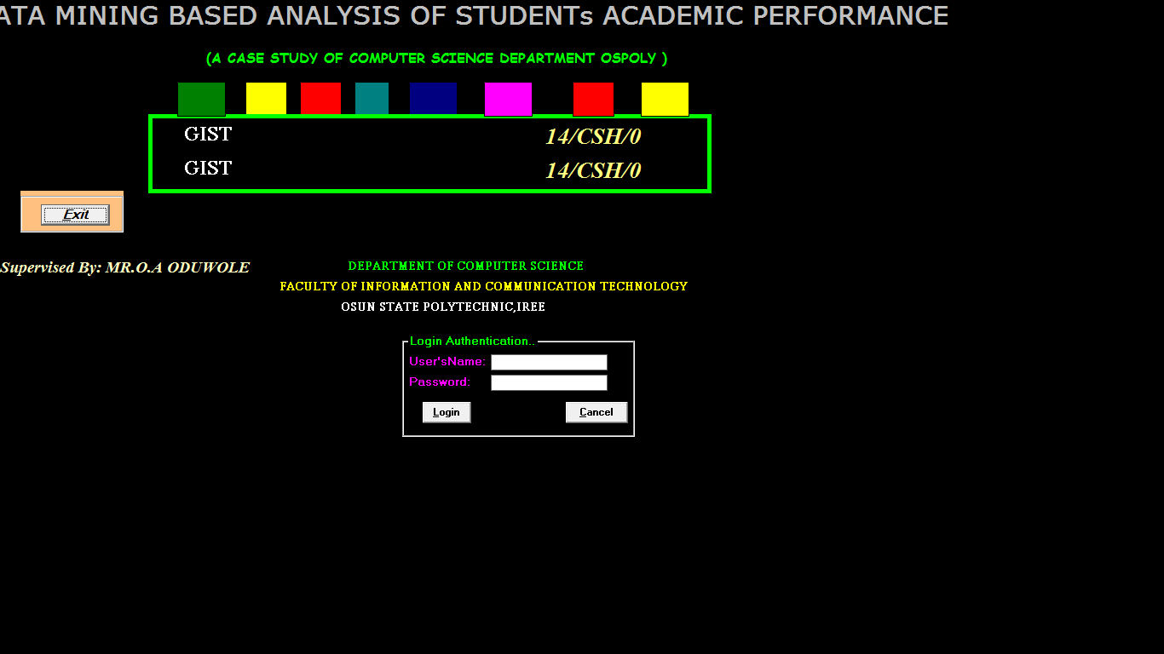
Figure 3.1: Home Page of the Data Mining Based Analysis of Students Academic Performance
3.2.2 ND Registration Page: This where student result will be registered. This can be done by entering student data to the box provided including picture as shown figure 3.2.
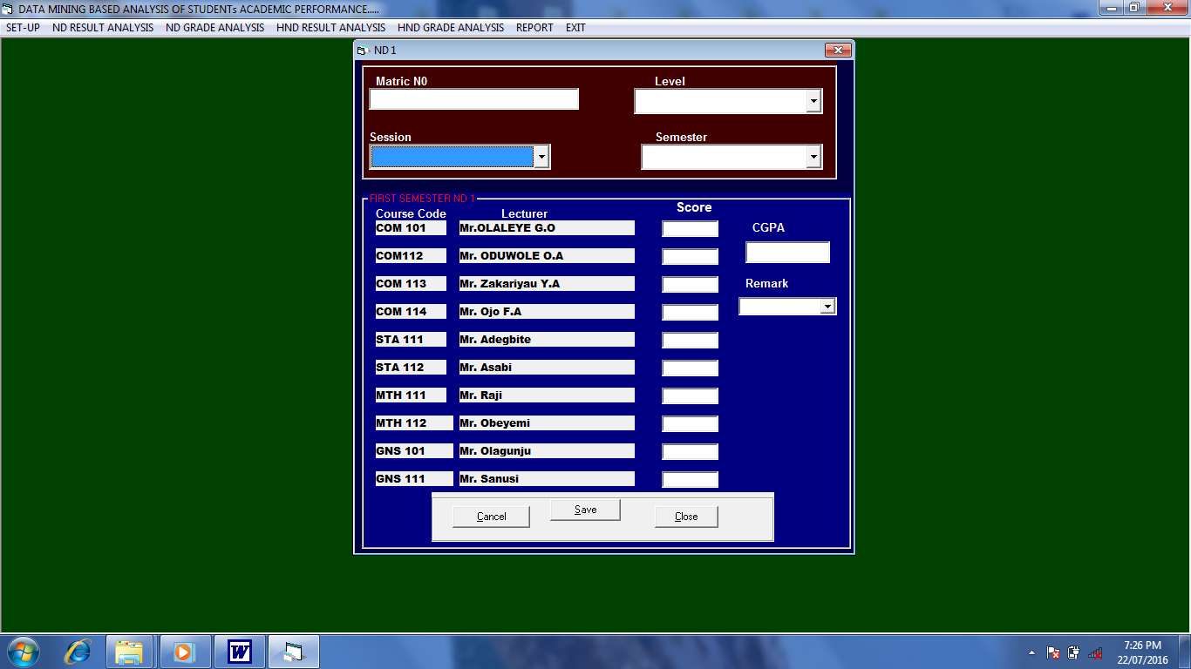
Figure 3.2 : ND Registration Page of the Data Mining Based Analysis of Students Academic Performance
3.2.3 HND Registration Page: This where student result will be registered. This can be done by entering student data to the box provided including picture as shown figure 3.3.
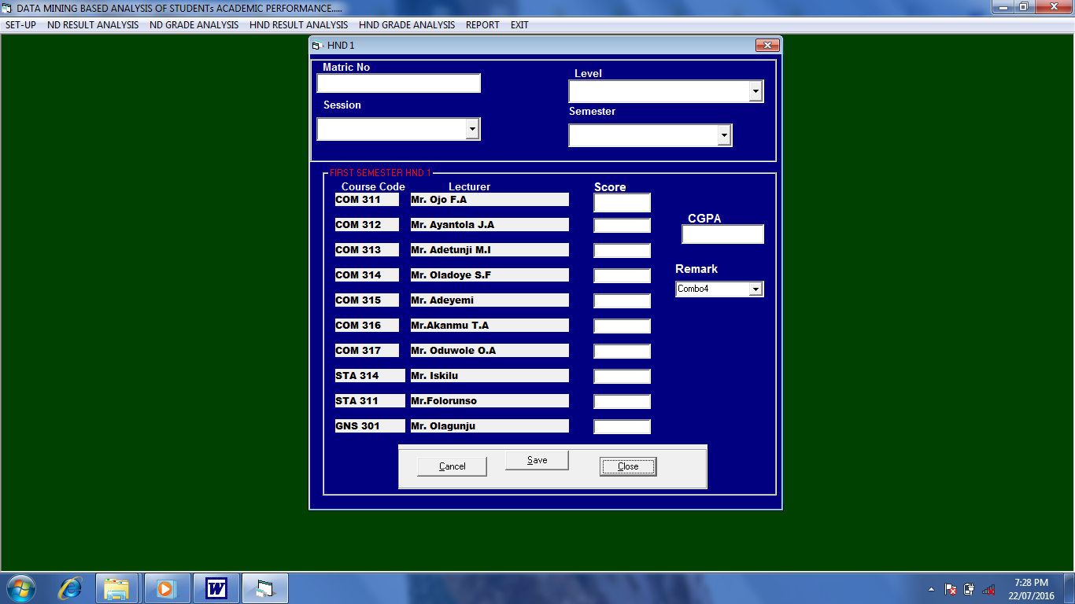
Figure 3.3 : HND Registration Page of the Data Mining Based Analysis of Students Academic Performance
3.2.4: ND Result Analysis Page: This where student result will be analysis. This can be done by entering student data to the box provided including picture as shown figure 3.4.
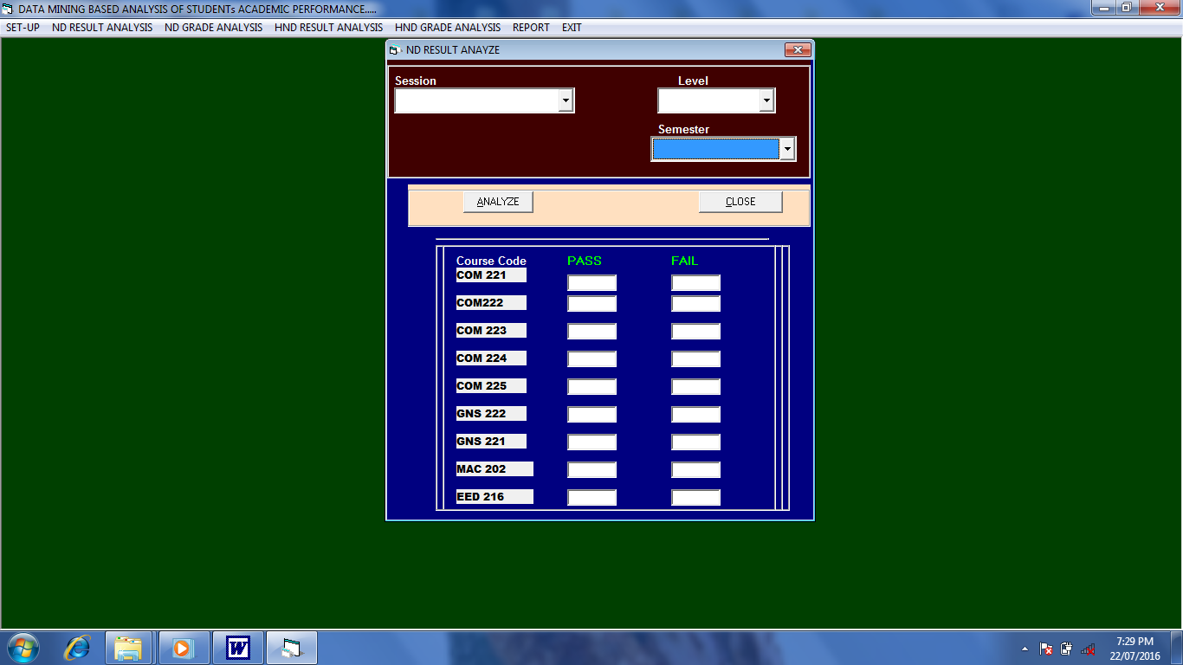
Figure 3.4: ND Result Analysis Page of the Data Mining Based Analysis of Students Academic Performance
3.2.5: ND Grade Analysis Page: This where student result will be analysis. This can be done by entering student data to the box provided including picture as shown figure 3.5.
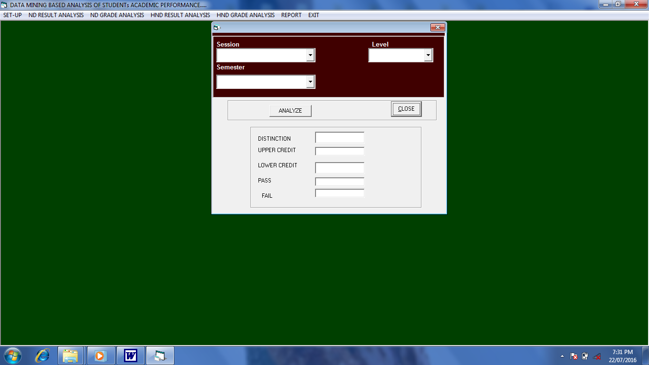
Figure 3.5: ND Grade Analysis Page of the Data Mining Based Analysis of Students Academic Performance
3.2.6: HND Result Analysis Page: This where student result will be analysis. This can be done by entering student data to the box provided including picture as shown figure 3.6.
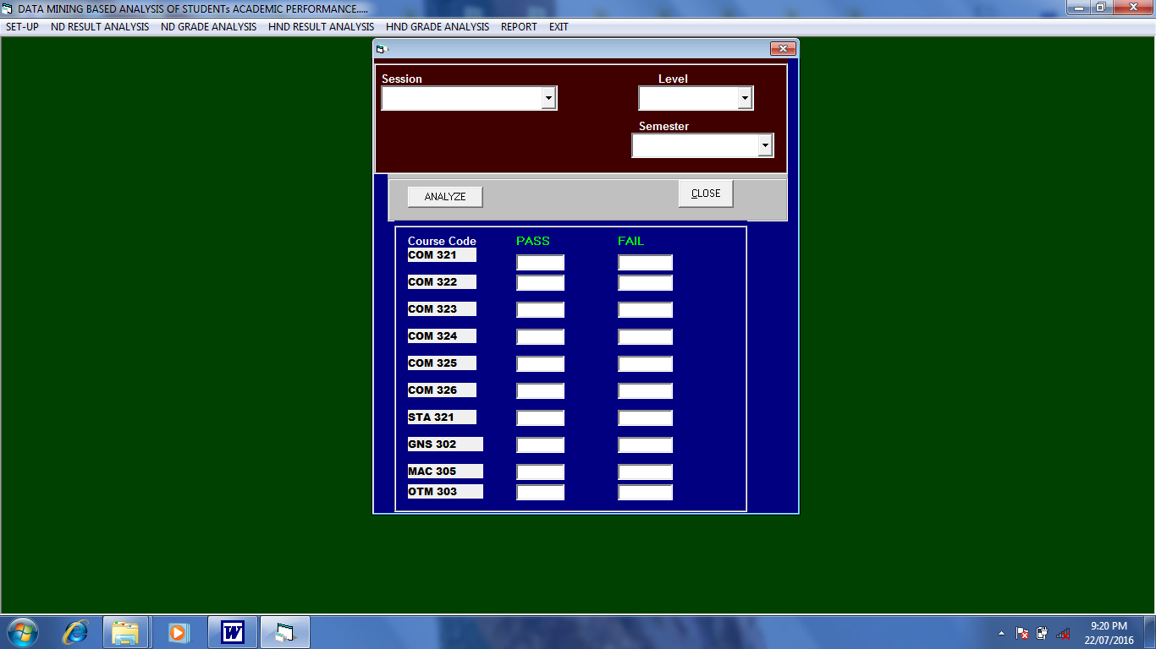
Figure 3.6: HND Result Analysis Page of the Data Mining Based Analysis of Students Academic Performance
3.2.7: HND Grade Analysis Page: This where student result will be analysis. This can be done by entering student data to the box provided including picture as shown figure 3.7.
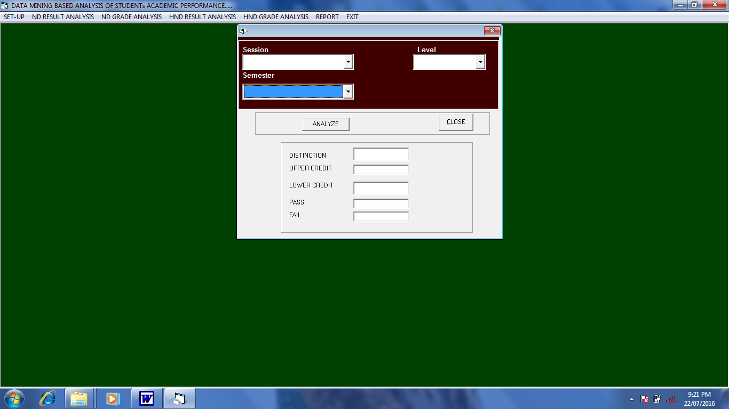
Figure 3.7: HND Grade Analysis Page of the Data Mining Based Analysis of Students Academic Performance
3.2.8: ND Combine report page: This page is to produce student registration report as shown figure 3.8.
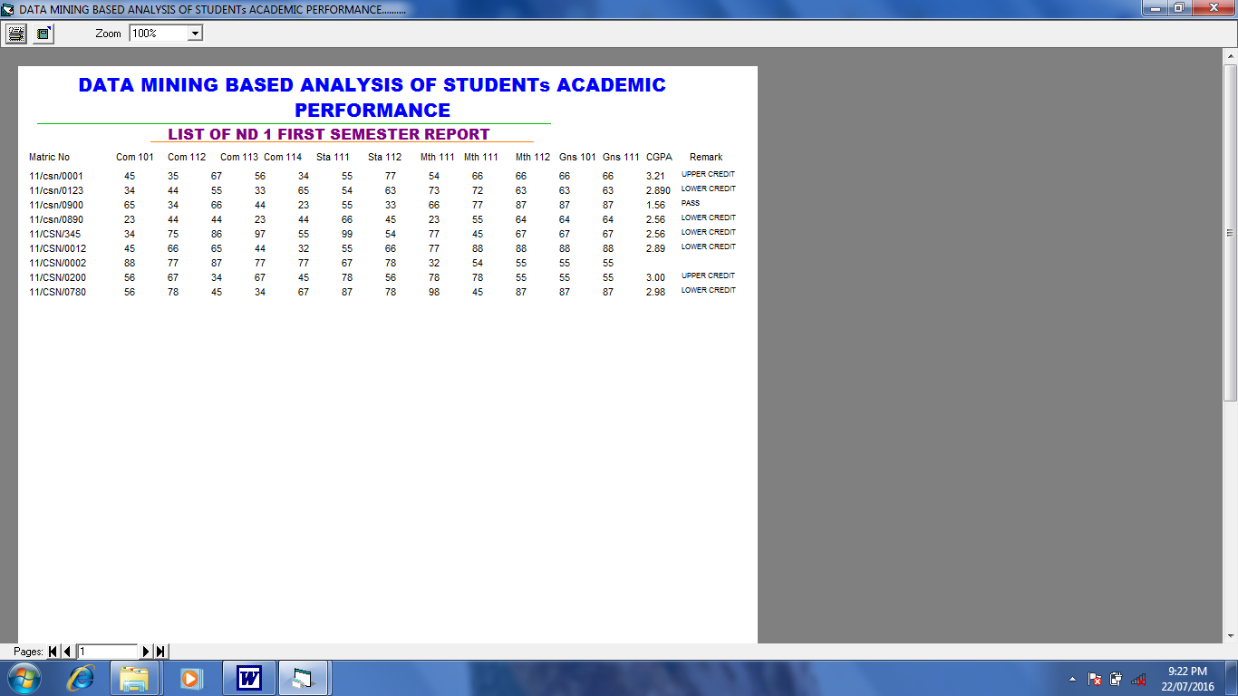
Figure 3.8: ND Combine report page of the Data Mining Based Analysis of Students Academic Performance.
3.2.9: HND Combine report page: This page is to produce student registration report as shown figure 3.9.
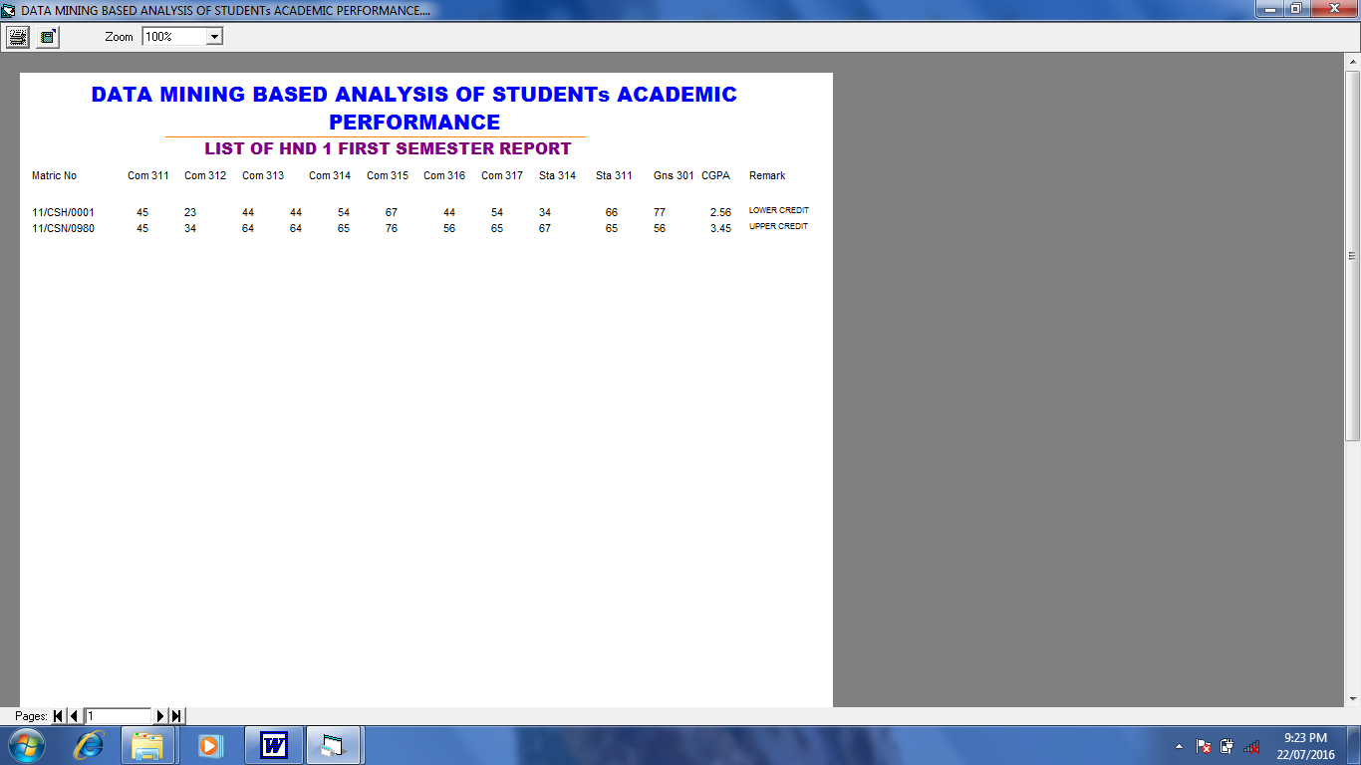
Figure 3.9: HND Combine report page of the Data Mining Based Analysis of Students Academic Performance.
3.3 System Implementation
The system was implemented using Visual Basic 6.0 while Ms-Access is used as the Database and Macromedia Fireworks will be used in designing the input and output interface because of the following:
i. It is user friendly.
ii. Visual basic provides a comprehensive interactive and context-sensitive online help system.
iii. Visual basic coordinate with third party vendor product.
iv. Its flexibility.
v. Its simplicity.
The phase is the most vigorous and time consuming part. It is found that any error occur is corrected here.

3.4 Evaluation of the Developed System
3.4.1 Evaluation Criteria
Evaluation of the developed system was carried out based on the following criteria:
i. Usability
ii. Speed

3.4.2 Evaluation of Methodology
The developed system was evaluated by administering questionnaire on 60 users whose responses were collected and used for the analysis of the result.

CHAPTER FOUR
4.0 RESULT AND DISCUSSION
4.1 Results
The results of the evaluation of the developed system are as presented in tables 4.1, 4.2 and figures 4.1 and 4.2.
Table 4.1: Responses of users on usability of the developed system
The developed system is easy to use | Frequency | Percentage
Strongly Agree | 30 | 50%
Agree | 15 | 25%
Disagree | 10 | 16.67%
Strongly Disagree | 5 | 8.33%
Total | 60 | 100%

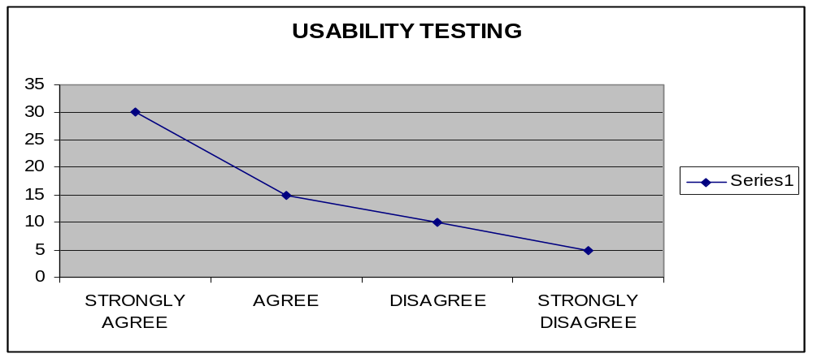
Figure 4.1 Graphical Representation of Reponses of the users on Usability of the developed system

Table 4.2: Responses of users on speed of processing of the developed system
The developed system is fast | Frequency | Percentage
Strongly Agree | 40 | 66.67%
Agree | 10 | 16.67%
Disagree | 6 | 10%
Strongly Disagree | 4 | 6.67%
Total | 60 | 100%

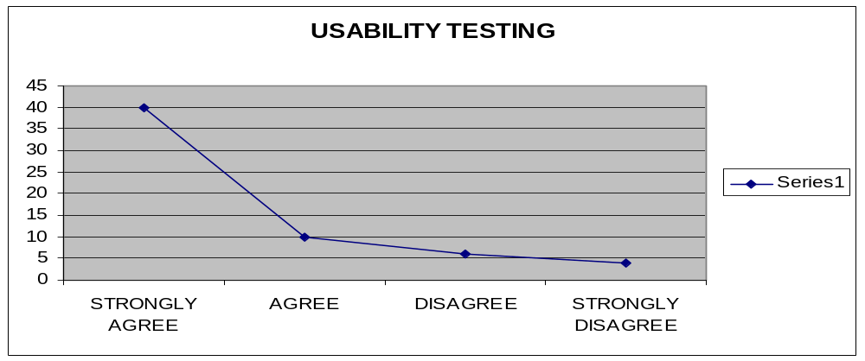
Figure 4.2 Graphical Representation of Reponses of the users on speed of the developed system

  - Discussion
The results of the evaluation of the developed system showed that 45 out of 60 users agreed that the system is easy to use. Also 50 out of 60 users agreed that the system is fast while 10 users disagreed.
Hence, this that shown a good majority of the respondent that made use of the system find it to be user friendly and fast in operation.

CHAPTER FIVE

5.0 CONCLUSION AND RECOMMENDATION
5.1 Conclusion
In this project, a Data Minig Based Analysis of Students Academic Performance was designed and implemented using Visual Basic 6.0 Programming language. The developed system was also evaluated based on accessibility and usability of the system.
It is therefore concluded that a Data Mining Based Analysis of Students Academic Performance that is capable of providing a user friendly and accessible means of students academic performance has been developed.
Thereby, establishing the fact that objectives of the work has been achieved.

5.2 Recommendation
It is recommended that :
i. It is recommended for further studies that the developed system be improved to provide in on-line access for Data Mining Based Analysis of Students Academic Performance.
ii. The developed system should be used by the Data Mining Based Analysis of Students Academic Performance of Computer Science Department in Osun State Polytechnic, Iree to ensure timely delivery of results on analysis of students academic performance.

REFERENCES
Amazon. Com (2005). An overview of Data Mining Techniques retrieved ocotber 27 2006 from http:// www. Amazon com /exex/obidos.htm.

Anderson U. (2006). Data Mining what mining, retrieved December 17, 2006 from
http:// www.anderson.ucla.edu/facult/teacher/technologies/palace/datamining htm.

Bing, L. (2007). Web Data Mining: Exploring Hyperlinks, Contents and Usage Data. Springer,
ISBN 3-540-37881-2.

David reilly (2004). Data migration techonology and its implication.Retrived noverber 20,
2006 from http:// www.davideilly com /topies/ software agents

David reilly (2005). Data Migration Techonology and its implication.Retrived April 8,
2007 http:// www. Jmp.com/ads/adwords/ stagahic com

Fayyad U,.M piatesky Shapiro g and smyth p. (1996). From Data Minng to knowledge
discovery in database.

Frawley, W., Piatetsky-Shapiro, G. and Matheus, C. (1992). Knowledge Discovery in
Databases. AAAI/MIT Press.

Fredrick, R. (2003). The Text Mining Handbook. Cambridge University Press, ISBN 978-
521- 83657-9.

Filo W.D(1982). Data Mining (Sometimes called data or Knwledge discory) is the process of analysising data from difference perpectives and summarizing.

Hand, D., Mannila, H. and Smyth, P. (2001). Principles of Data Mining, The MIT Press.

Jones(1980). Identity all input data to the software and organize in a hierarchical manner.

Macro, C. (2001), Mastering Viaul 6.0 USA sybex incorporation.

Stasoft (2005). An Introduction to Data Mining retrieved December 21,2006 from
http:// www. Stasoft. Com/textbook/glosd. Html

Sgelio E.F(1992). Data Mining can be used to uncover patterns in data sample.

Solio G.W(1985). Although Data Mining is a relatively new terms.

